INNERPAGE 2

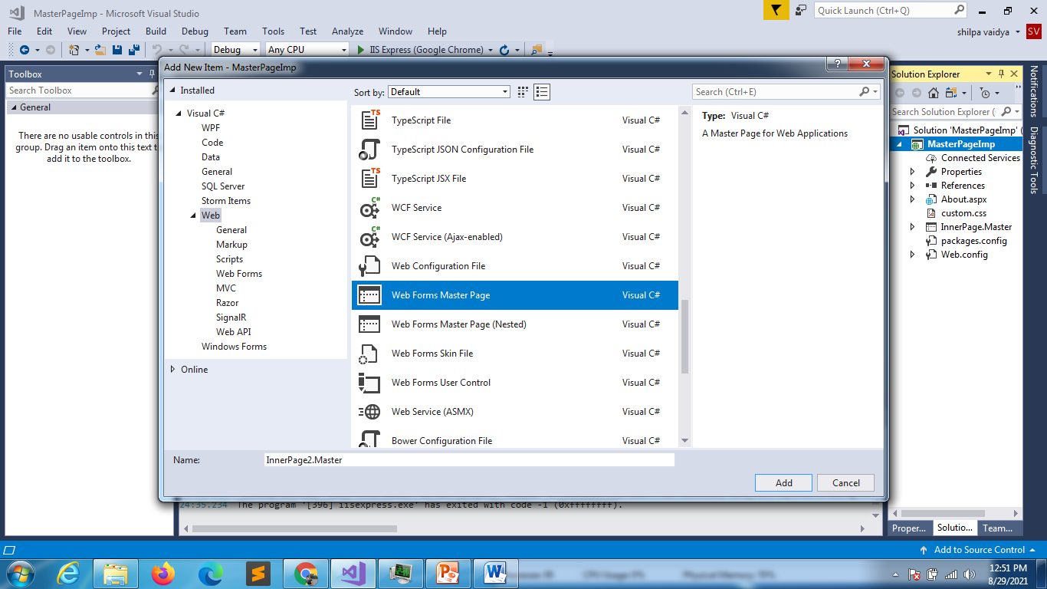

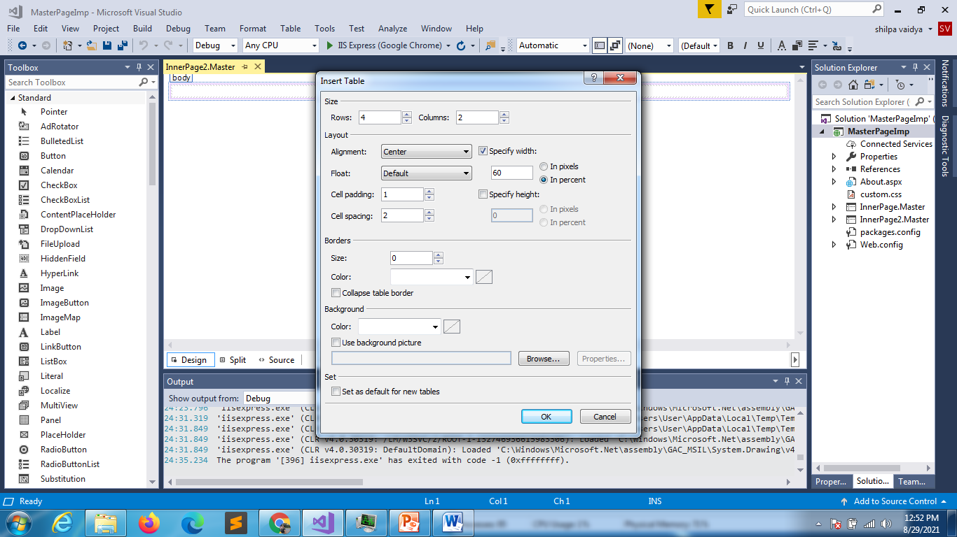

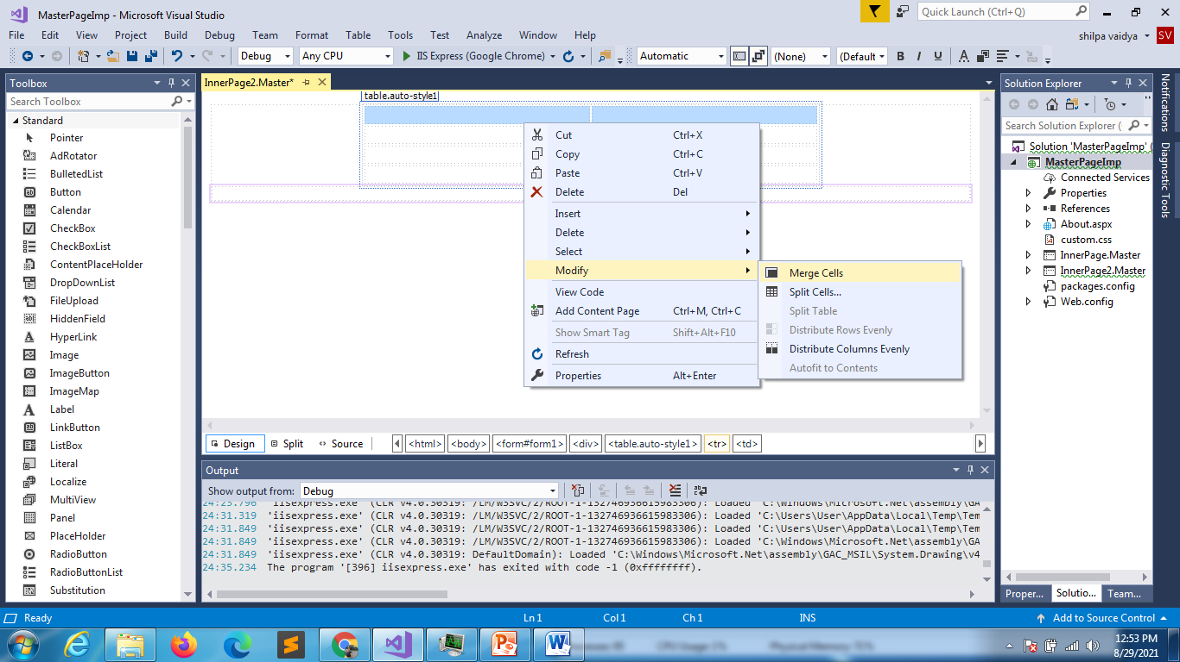

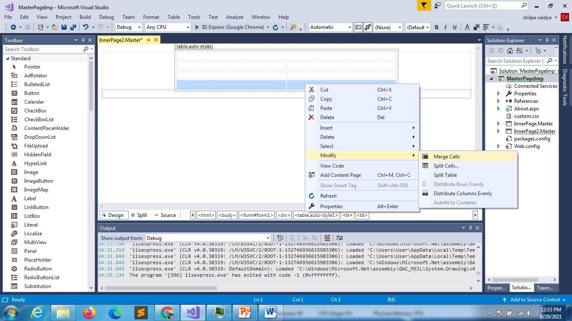

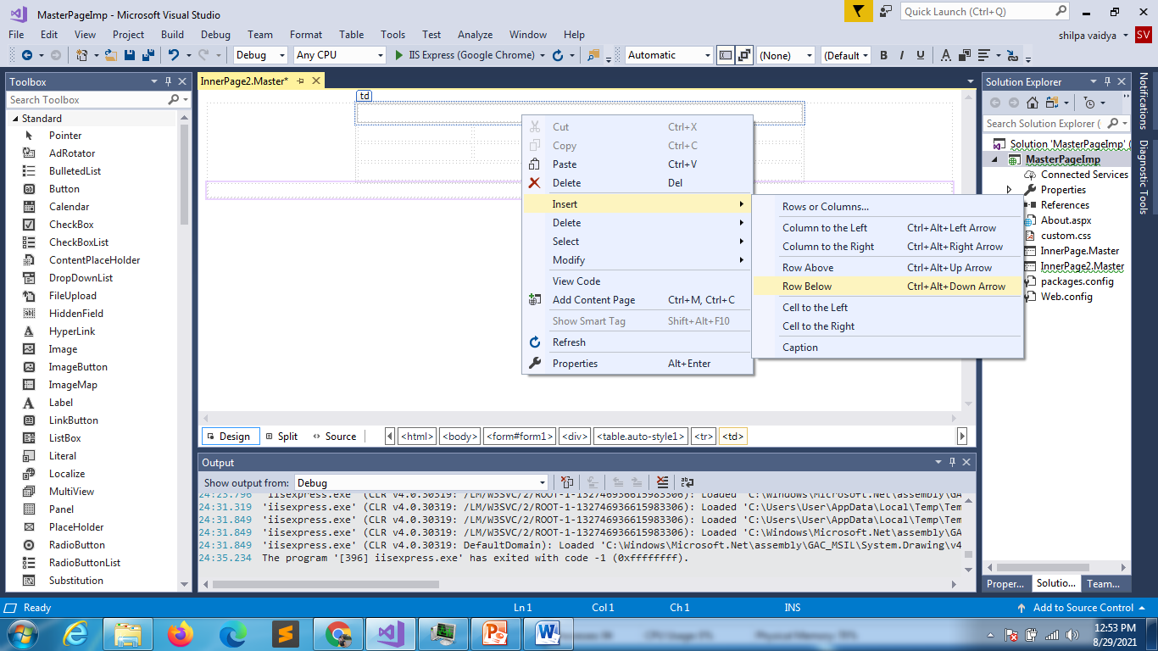

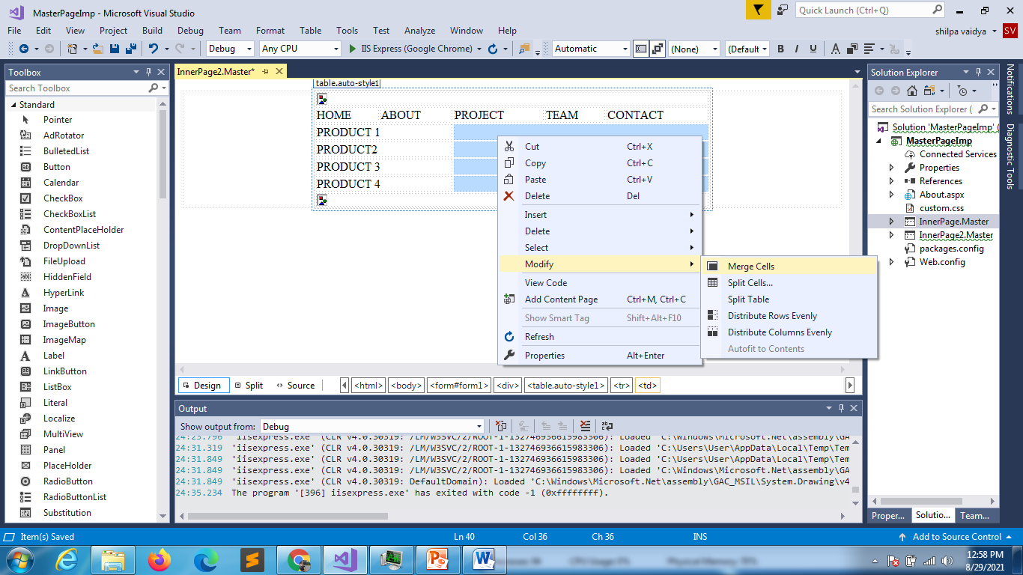

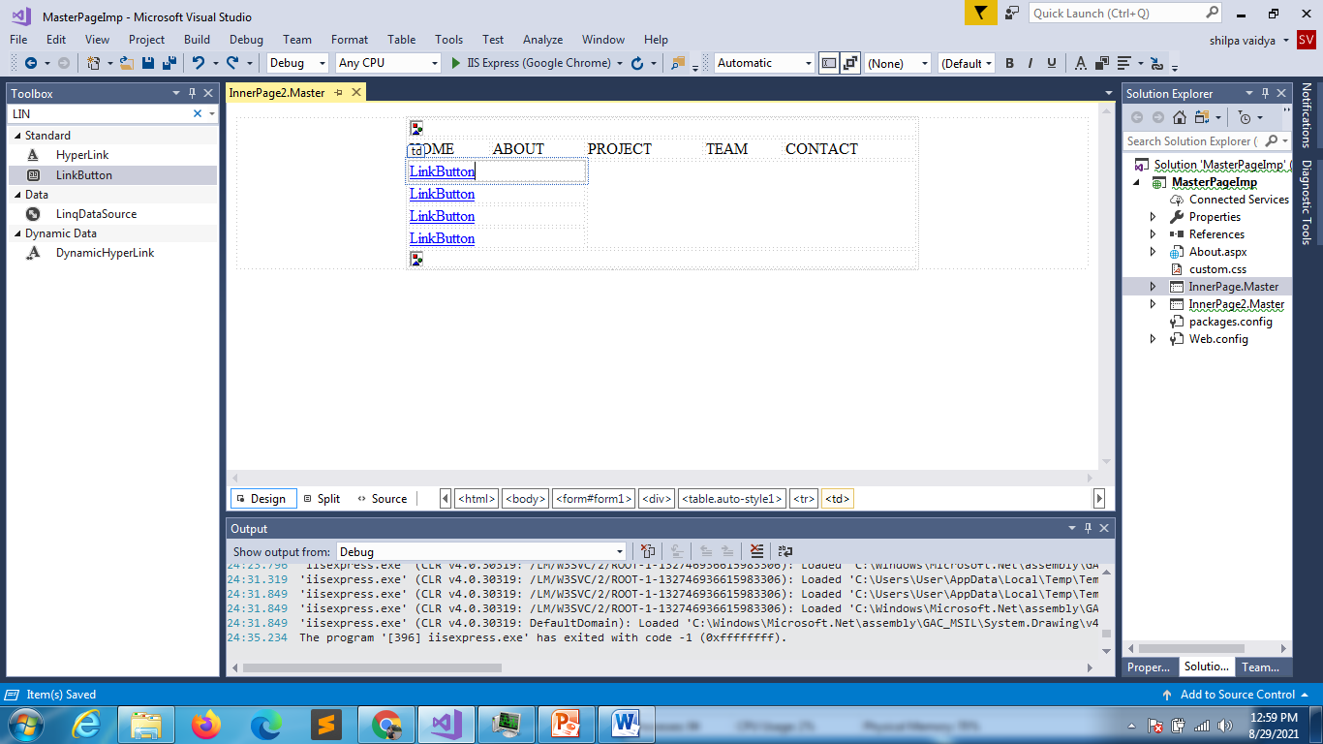

<%@ Master Language="C#" AutoEventWireup="true" CodeBehind="InnerPage2.master.cs" Inherits="MasterPageImp.InnerPage2" %>

<!DOCTYPE html>

<html>

<head runat="server">

    <title></title>

    <asp:ContentPlaceHolder ID="head" runat="server">

    </asp:ContentPlaceHolder>

    <style type="text/css">

        .auto-style1 {

            width: 60%;

        }

        </style>

</head>

<body>

    <form id="form1" runat="server">

        <div>

            <table align="center" class="auto-style1">

                <tr>

                    <td colspan="5">

                        <asp:Image ID="Image1" runat="server" />

                    </td>

                </tr>

                <tr>

                    <td>HOME</td>

                    <td>ABOUT</td>

                    <td>PROJECT</td>

                    <td>TEAM</td>

                    <td>CONTACT</td>

                </tr>

                <tr>

                    <td colspan="2">

                        <asp:LinkButton ID="LinkButton1" runat="server">PRODUCT 1</asp:LinkButton>

                    </td>

                    <td colspan="3" rowspan="4">&nbsp;</td>

                </tr>

                <tr>

                    <td  colspan="2">

                        <asp:LinkButton ID="LinkButton2" runat="server">PRODUCT 2</asp:LinkButton>

                    </td>

                </tr>

                <tr>

                    <td  colspan="2">

                        <asp:LinkButton ID="LinkButton3" runat="server">PRODUCT 3</asp:LinkButton>

                    </td>

                </tr>

                <tr>

                    <td  colspan="2">

                        <asp:LinkButton ID="LinkButton4" runat="server">PRODUCT 4</asp:LinkButton>

                    </td>

                </tr>

                <tr>

                    <td colspan="5">

                        <asp:Image ID="Image2" runat="server" />

                    </td>

                </tr>

            </table>

        </div>

    </form>

</body>

</html>

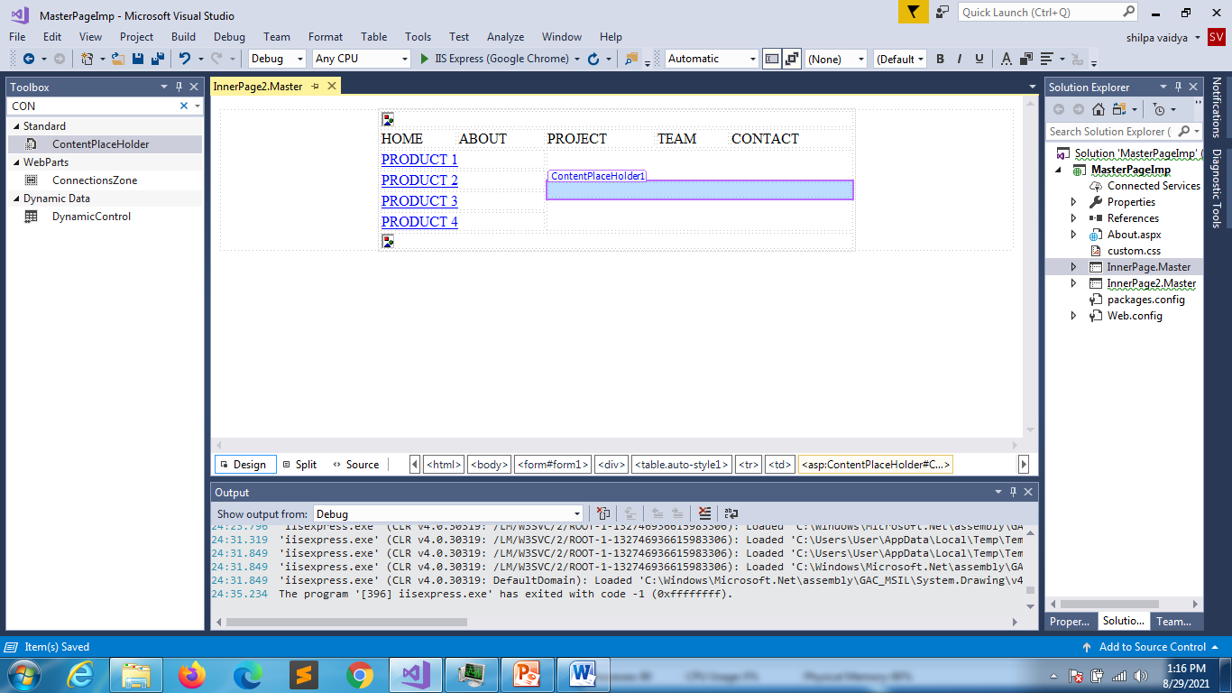

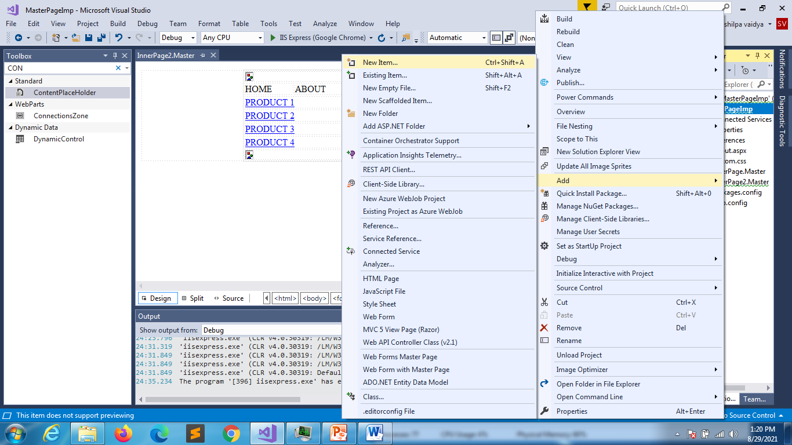

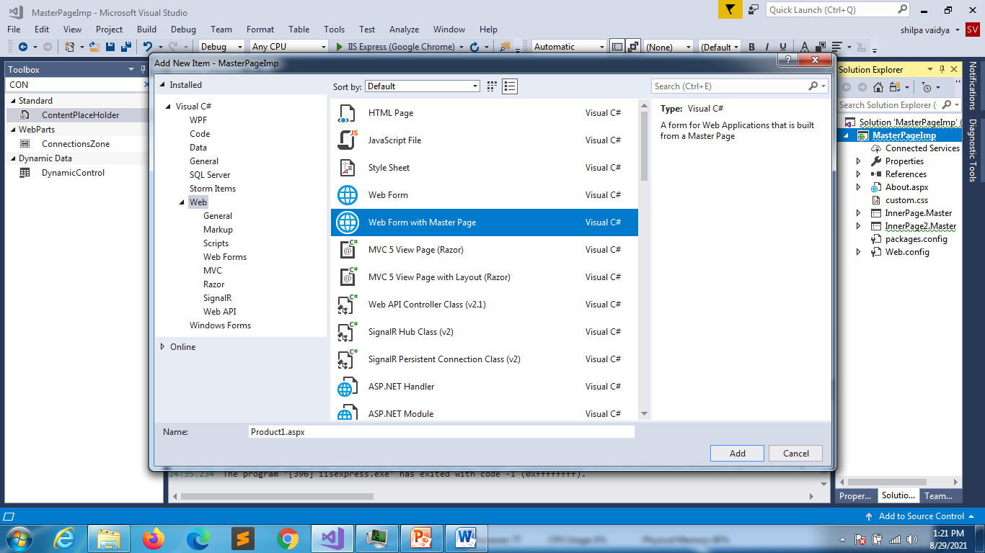

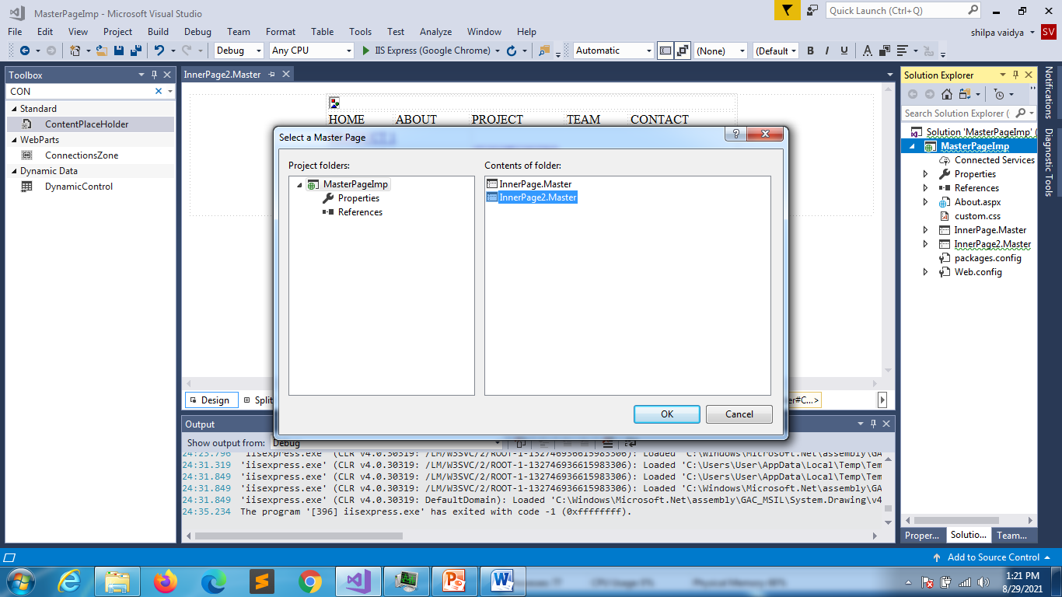

<%@ Page Title="" Language="C#" MasterPageFile="~/InnerPage2.Master" AutoEventWireup="true" CodeBehind="Product1.aspx.cs" Inherits="MasterPageImp.Product1" %>

<asp:Content ID="Content1" ContentPlaceHolderID="head" runat="server">

</asp:Content>

<asp:Content ID="Content2" ContentPlaceHolderID="ContentPlaceHolder1" runat="server">

   <h1> Product name: The name of a specific product a customer is viewing</h1>

   <h1> Short description: A brief description of a specific product a customer is viewing</h1>

   <h1> Price/product availability: How much a specific product costs and status on whether it is in-tock or not (potentially including a low inventory notice)</h1>

   <h1> Buy button: A button on a product page that users can click to immediately make a purchase</h1>

   <h1> Size/Color: The color and size options of a specific product</h1>

   <h1> Quantity to Purchase: Allows users to pick how many of the same product they wish to</h1></asp:Content>